Click on Teams in Office 365

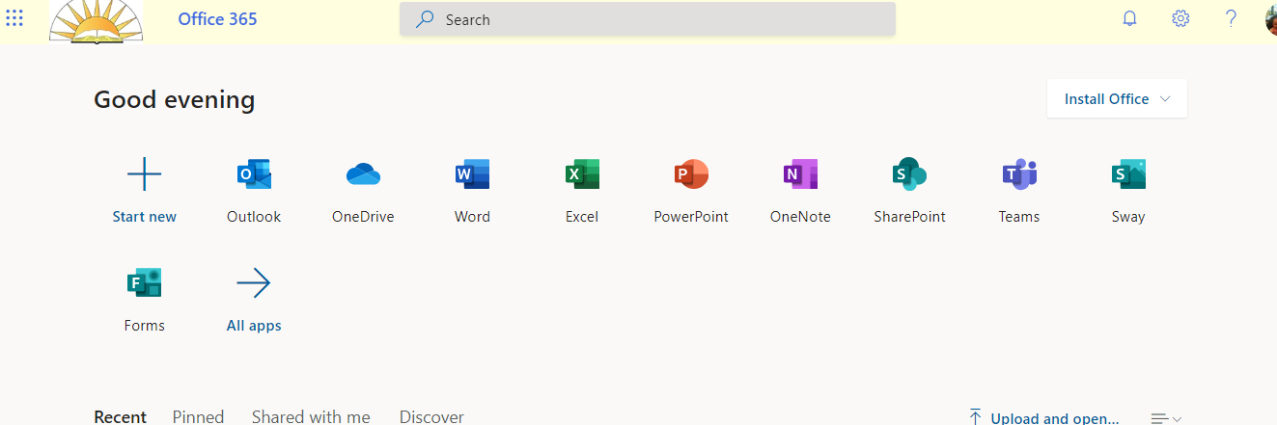

Click on “join or create team”

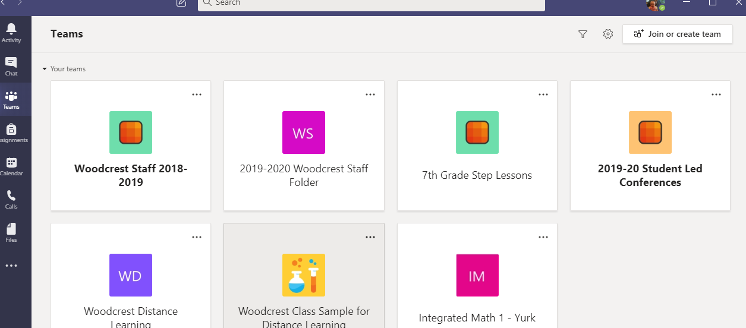

Click on “Join a team with code” and enter your code EXACTLY as it appears above. (Copy and paste it to avoid mistakes!)

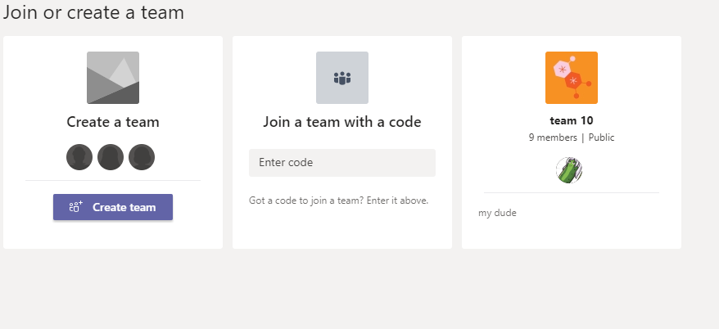

After entering code, hit join team button.

That’s all there is to it!!